St. William
Sunday February 8, 2026 www.superiorcatholics.org



Saturday, February 7th 6:00 pm
People of the Parish
Saturday, February 14th 6:00 pm
People of the Parish



Saturday, February 14th 6:00 pm
Reader Becky Stuart
Wine Eric Stuart

MASS INTENTIONS
We are in need of Mass intentions.
Mass Intentions are a meaningful way to honor the memory of a loved one or to offer prayers for special intentions such as health, birthdays, anniversaries, or times of need. A suggested donation of $20 may be offered for each intention. Please contact the parish office to request a Mass Intention.

Phone: 715-394-7919
Email: haswoffice@gmail.com
Stop By on Mondays or Wednesdays from 9am-Noon

ST. WILLIAM’S FAMILY BINGO
Tuesday, March 3rd
Concessions will be available at 5:30
Bingo starts at 6:30!
Come for a fun evening of Bingo, Food and Prizes. $200 in prizes to be given away and a 50/50 raffle. Bring your family and friends. Bingo is free!



St. William 2025/2026
CSA Goal: $5,605.00

ENCOUNTERING CHRIST, TRANSFORMING LIVES

Happy New Year!

Weekly Contributions
January 31st, 2026

Envelopes…….…….….……$ 185.00
Loose……..………………….$ 0.00
Catholic Herald…..…………$ 60.00
Online Giving………….…..$ 327.37

Thank you to all of our parishioners who continue to support our parish at Mass, on Line, or by Mail.



Pray for Their Health and Welfare

Fr. Ron Olson Fr. Jim Tobolski Mary Kunz Maryann Grymala Krista Hudacek Lambert Wendy Johnson Carolyn Ward Carl Schultz Julia Dalbec Chris Litchke Marreddy Yannam
Scott Hockenbrock Duane Johnson

Pray for Those in the Armed Services

Nathaniel Grymala Joe Austin
Nathan Blair Brandon Anderson



Fifth Sunday in Ordinary Time
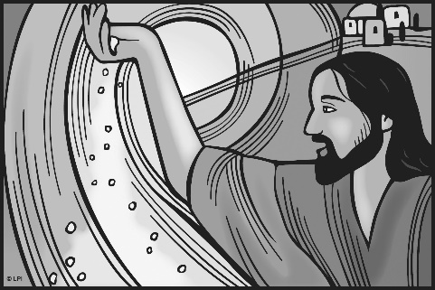
Jesus said to His disciples, “You are the salt of the earth. But if salt loses its taste, with what can it be seasoned? You are the light of the world. A city set on a mountain cannot be hidden.” - Mt 5 : 13a – 14

ST. WILLIAM’S PIE AND PASTY SALE

Prebaked Dutch Apple
Pies - $20 each
Frozen Pasties for sale. $5 each
Call Amy at 218-590-7354 to order or you may pick up after Mass on Saturdays.




WEEKLY MEDITATION
SDCCW Mary Jane Morancyk Hennessy Scholarships
The Superior Diocesan Council of Catholic Women will award four (4) $1,000 scholarships to women completing their second year of post high school education or continuing their education for career advancement or returning to the work field.
Applications may be obtained by contacting the SDCCW Scholarship Committee – Mary Werner
Phone: (715) 748 – 4709
Email: werner@tds.net
Website: sdccw-wisconsin.weebly.com
Applications open Feb. 1st & are due May 15th, 2026

Let's explore some of the themes in the readings for the Epiphany of the Lord.

1st Reading - Isaiah 60:1-6
- Jerusalem rises up in the shining light of the Lord's glory.
- By this light people will come together, praising the Lord.
Psalm - 72:1-2,7-8,10-13
- "Lord, every nation on earth will adore you."
- God endows the king with justice and right judgment to care for the people.
2nd Reading - Ephesians 3:2-3a,5-6
- The Holy Spirit has revealed to the apostles and prophets that the Gentiles are coheirs of God's grace.
- As members of the same body, they are copartners in the promise of Christ.
Gospel - Matthew 2:1-12
- The Magi, guided by a star, come to Jerusalem seeking the king of the Jews.
- They go to Bethlehem, where they encounter Jesus and present him with gold, frankincense, and myrrh.

Fr. Andrew

Question for Children: In your life, who helps you to see Jesus in other people such as a classmate or a friend?

Question for Youth: Life can sometimes be rough: losing your home, moving, feeling fear or danger. How do you experience God being and staying with you in such times?

Question for Adults: How this past week did you demonstrate God’s love at home and at work?


Readings for the week of January 4, 2026
Sunday: Is 60:1-6/Ps 72:1-2, 7-8, 10-11, 12-13
Eph 3:2-3a, 5-6/Mt 2:1-12
Monday: 1 Jn 3:22-4:6/Ps 2:7bc-8, 10-12a
Mt 4:12-17, 23-25
Tuesday: 1 Jn 4:7-10/Ps 72:1-2, 3-4, 7-8/Mk 6:34-44
Wednesday: 1 Jn 4:11-18/Ps 72:1-2, 10, 12-13
Mk 6:45-52
Thursday: 1 Jn 4:19-5:4/Ps 72:1-2, 14 and 15bc, 17
Lk 4:14-22a
Friday: 1 Jn 5:5-13/Ps 147:12-13, 14-15, 19-20
Lk 5:12-16
Saturday: 1 Jn 5:14-21/Ps 149:1-2, 3-4, 5 and 6a
and 9b/Jn 3:22-30
Next Sunday: Is 42:1-4, 6-7/Ps 29:1-2, 3-4, 3, 9-10
Acts 10:34-38/Mt 3:13-17

Lord, every nation on earth will adore you. -Psalm 72

RELIGIOUS EDUCATION

Religious Ed. Classes
Wednesday, January 7th in Cathedral Kress Hall. PreK – 6th grade classes from 5:30-6:30pm. 7th grade - Confirmation class from 7-8pm.

CATHEDRAL SCHOOL NEWS

January 5th - Classes Resume

SOCIETY OF ST. VINCENT DE PAUL

A PRAYER FOR EPIPHANY

O God, as you guided the Magi by the light of a star, may Jesus be our light and may we faithfully offer Christ the gold of a living faith, the incense of our worship, and the myrrh of compassion. Amen

Looking for a way to serve our neighbors in the New Year? Join us at our next meeting on Tuesday, January 13th in Kress Hall at 6pm - elevator entrance. Everyone is welcome!!

Voicemail: 715-398-4039
Mailing Address: SVDP P.O. Box 98
Superior, WI 54880

CLUSTER NEWS

MASSES AT ST. MARY HOSPITAL-SUPERIOR
Masses are celebrated at St. Mary’s Hospital, Superior, on Wednesdays at 11:15 A.M.

EUCHARISTIC ADORATION IN OUR CLUSTER:

Cathedral – every Thursday from 1-3pm
St. Anthony, L.N. – every Thursday from 9-10am
St. William – 1st Saturday from 5:30-6pm
Holy Assumption – 1st Friday from 7:30-8:00am
St. Anthony, Sup. – 1st Tuesday from 8-8:30am


PRAYER GROUP MEETING
Monday, January 5th
6:00 PM Cathedral – Kress Hall
All are welcome!
Any questions please call Anna Marie ~ 715-392-1673
ST. WILLIAM’S FAMILY BINGO
Tuesday, January 6th
Concessions will be available at 5:30
Bingo starts at 6:30
Come for a fun evening of Bingo, Food and Prizes. $200 in prizes to be given
away and a 50/50 raffle.
Bring your family and friends. Bingo is Free.



PASTY SALE
The Knights of Columbus, Superior Council 499 will hold a Pasty Sale on Friday & Saturday, Jan. 9 & 10. The cost is $5.00 for a 12 oz. pasty (filling: beef, potatoes, carrots, onions & rutabagas). Pasties will be available for pick-up between 12:00 Noon & 4:00 PM on Friday & 12:00 Noon & 4:00 PM on Saturday at St. Anthony Church in Superior. Orders of 40 or more will not be available for pick-up until 2:00 PM on Friday. Pre-ordered pasties not picked up by 2:00 PM on Saturday will be sold on a first come/first serve basis until 4:00 PM. Online orders can be made by using the address below or by calling as follows: Darryl at 218-349-9165, Tom at 715-392-2061, or Al at 715-364-2664. Leave a message if you get no answer.

The Cathedral Book Club 2025-2026

We meet in the Cathedral Parish Office at 6:30 pm. All are welcome to join us.

Jan. 14 - Ghost Soldiers by Hampton Sides
Feb. 4 - Acts of the Apostles
March 11 - Hope: The Autobiography by Pope Francis
May 6 - Golden Doves by Martha Hall Kelly

CATHOLIC MEN’S GROUP
Catholic Men’s Group will meet on Monday’s at 7:00 p.m. once a month in Kress Hall. Men of all ages are invited for Catholic fellowship and discussion.

Catholic Men’s Group 2025-2026: Into the Breach
Jan. 26 – Isaac Hopke presents on Brotherhood
Feb. 23 – Bill Kovaleski presents on Suffering
Mar. 30 – Brad Montgomery presents on Masculinity
Apr. 27 – Tom Tracy presents on Prayer
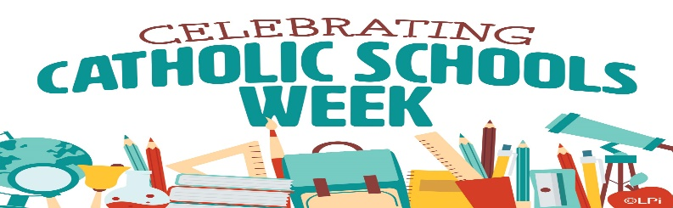

CATHOLIC SCHOOLS WEEK

Catholic Schools Week 2026: Rooted in Faith, Focused on the Future!

Join us in celebrating Catholic Schools Week 2026, running from Sunday, January 25th, through Saturday, January 31st. This is a special time dedicated to honoring the outstanding education provided by the 14 Catholic Schools throughout our Diocese.

These schools highlight the unique qualities that make them exceptional: a rigorous academic foundation rooted deeply in faith, community, and service. We invite you to participate in the special events, open house, and activities planned throughout the week. Let’s come together to celebrate our shared commitment to excellence in education and the formation of strong, faith-filled leaders for the future of our Church and communities.

As we observe this important week, we also ask you to support the Special Diocesan Collection for Catholic Schools. The collection provides an immediate and essential source of support for our schools, allocated based on student enrollment. Your generous response is a beautiful expression of discipleship and unity with Catholic school communities across northern Wisconsin. Your gift will help ensure a vibrant future for Catholic education and a strong Church.


Formed QR Hallow QR


"The Catholic Church is working diligently to prevent sexual abuse by parish employees, volunteers, deacons, and priests. If you have been sexually abused by someone associated with the Church and would like to report or discuss the experience, we urge you to contact:

Bonnie Thom (715) 718-1110.

The Diocese of Superior welcomes your call and understands how difficult it may be to reach out in this situation. The phone number provided is confidential and dedicated solely to these calls. Know that your call will be treated with respect, dignity, and compassion. The Diocese of Superior is bound by civil and canon law to report sexual abuse of a minor to civil authorities. Anyone who believes that they have been sexually abused is strongly encouraged to report as well."
If you are new to our parish and would like to register as a member, please call the office at 715-394-7919 or go to https://superiorcatholics.org and click
on Our Parishes, Become a Member &
Parish Census, and fill out the form for
Holy Assumption or St. William.



ONLINE GIVING
If you would like to sign up for Online Giving,
go to our website https://superiorcatholics.org scroll down, click “Giving” and then
click Holy Assumption or St. William
then fill out the form for our parish.

ANOINTING
On the second weekend of each month, Father will be anointing anyone that wishes to receive the sacrament after Mass. Anointings are available for sickness, preparation for a doctor’s visit etc. They are available for both physical and mental health.

SENIOR MEALS AT HOLY ASSUMPTION
Mondays through Thursdays. Please reserve your meal at least 24 hours in advance to Senior Connections at 715-394-3611. Donation $6.00

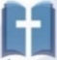
St. William 2025/2026
CSA Goal: $5,605.00

ENCOUNTERING CHRIST,
TRANSFORMING LIVES




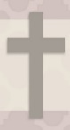



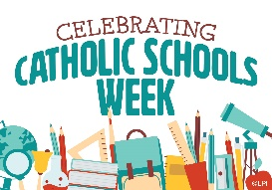

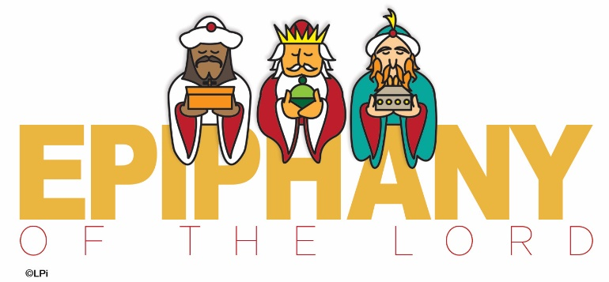

ST. WILLIAM’S FAMILY BINGO
Tuesday, January 6th
Concessions will be available at 5:30
Bingo starts at 6:30. Bingo is free.





could you put in a thank you for all who helped decorate the church. And the choir for their Christmas Eve music?

The 2026 Catholic Calendars are available at the entrance of the church.

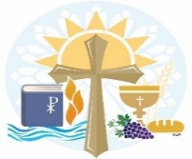

ST. WILLIAM’S PIES FOR SALE
Dutch Apple Pie - Take and Bake (raw frozen)
Pecan Pie - Frozen and Baked (thaw & enjoy)
$20 each
Call Amy at 218-590-7354. Pick up after
Mass or make arrangements to pick up.











ST. WILLIAM’S FAMILY BINGO
Tuesday, January 6th

Concessions will be available at 5:30
Bingo starts at 6:30
Come for a fun evening of
Bingo, Food and Prizes

$200 in prizes to be given away
and a 50/50 raffle.
Bring your family and friends.
Bingo is free.

